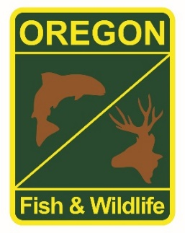

**State Fisheries Genetics Lab Tissue Sample Intake Form**

Please complete the top part of this form and send to: [kathleen.omalley@oregonstate.edu](mailto:kathleen.omalley@oregonstate.edu)

Make arrangements with us prior to dropping off the tissue samples and include a copy of this form with your samples.

**Project dropping off samples: Rogue Fish District**

**Person dropping off samples: Dan VanDyke**

**Phone: 541-826-8774 x234 Email:daniel.j.vandyke@state.or.us**

**Description of samples (e.g. species, collection locations, collection dates, collection methods, number of samples, life stage; may attach spreadsheet):**

**Hatchery Rogue spring Chinook. Location is Cole Rivers Hatchery at the upstream end to anadromy on the Rogue River. Samples collected from live adults with scissors from fin identified in protocol (can’t remember, either dorsal/caudal. All samples from week of sampling included in one container (batch sampling). Samples identified by date. Unknown number of samples.**

**If applicable, known origin (e.g. natural or hatchery): Majority of samples from ad marked fish. Some samples (not separated) from intact ad (wild) fish but not many.**

**Sample type (e.g. fin tissue, scale, muscle, etc): Fin tissue.**

**Storage method (e.g. dry, 95% ethanol, RNA later, etc): 95% ethanol**